Akinaka “Osho” Miura, DPT
Physical Therapist
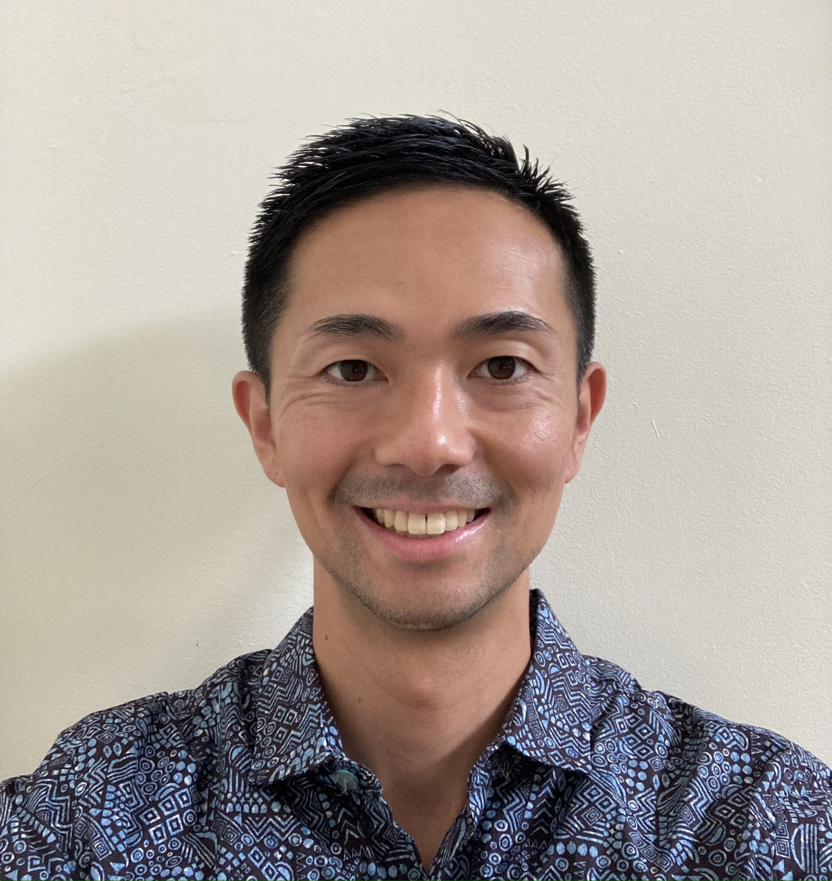
Osho received his doctorate degree in physical therapy from University of Puget Sound in 2014. He worked at an outpatient physical therapy clinic in Honolulu, Hawai'i for 9 years before continuing his career at Exeter Hospital. He treats a variety of orthopedic conditions and focuses on proper movement patterning. His treatment methods include of Strain-Counterstrain (osteopathic technique), joint mobilization and therapeutic exercises. Outside of work he enjoys playing basketball, surfing, hiking, trail running, and traveling.
Education | University of Puget Sound - Doctorate of Physical Therapy 2014  Seattle University - Bachelor of Science in Biology, minor in Psychology 2008
Specialties | Outpatient orthopedics  Osteopathic Strain-Counterstrain  Post-surgical rehabilitation  Return to sport rehabilitation

